SIMATS ENGINEERING
ASSESSMENT TOOL 3

COURSE CODE: CSA1402 COURSE NAME: COMPILER DESIGN

COURSE OUTCOME COVERED

CO5: Develop code optimization and Code Generation using DAG representation with data flow analysis to produce optimized target code ( BL3)

Assessment Tool Weightage: 10%

QUESTIONS: 30 Total Marks:60

Annexure A

MOCK INTERVIEW

Code of Conduct:

I _____M.Madhu Rushwika(192371066)_______________ (Name / Reg No) certify that this submission is my original work and that I have adhered to the guidelines specified for this assessment.
I understand that any violation of academic integrity rules will result in disciplinary action.

Signature of the student: M.Madhu Rushwika

Annexure A

MOCK INTERVIEW
QUESTIONS

1. What is a compiler?
2. What are the different phases of a compiler?
3. What is lexical analysis?
4. What is the role of a lexical analyzer?
5. What is a token? Give an example.
6. What is a lexeme?
7. What is the difference between token and lexeme?
8. What is a pattern in lexical analysis?
9. What are keywords and identifiers?
10. What are the common errors detected by a lexical analyzer?
11. What is syntax analysis?
12. What is the role of a parser?
13. What is a parse tree?
14. What is the difference between parse tree and syntax tree?
15. What is ambiguity in grammar?
16. What is left recursion?
17. Why should left recursion be removed?
18. What is left factoring?
19. What is predictive parsing?
20. What is the dangling else problem?

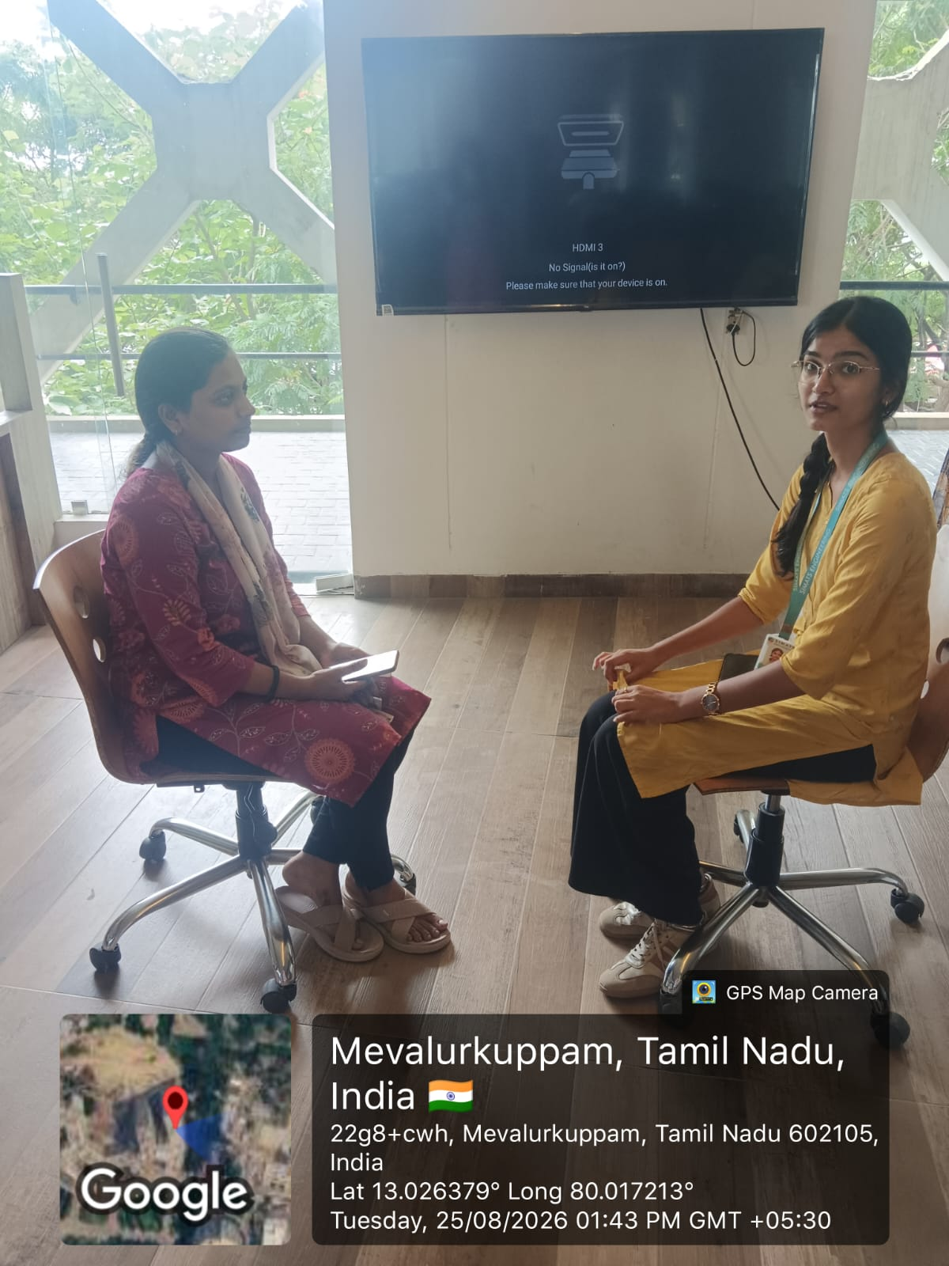

RUBRICS FOR CALCULATION:

Criteria | Weightage | Level 4 (Exemplary) | Level 3 (Proficient) | Level 2 (Developing) | Level 1 (Beginning)
Technical Knowledge | 25 | Demonstrates strong and accurate subject knowledge with in-depth understanding | Shows good knowledge with minor gaps | Basic knowledge with noticeable errors | Lacks fundamental technical knowledge
Problem Solving | 25 | Solves problems logically and applies concepts effectively in real scenarios | Applies concepts with moderate accuracy | Limited problem-solving ability; requires guidance | Unable to solve or apply concepts
Analytical Thinking | 15 | Analyzes questions critically and provides well-structured, logical answers | Provides reasonable analysis with some structure | Superficial or partially structured responses | No analytical thinking was demonstrated
Communication | 15 | Communicates clearly, confidently, and professionally with proper terminology | Communicates well with minor hesitation | Communication lacks clarity or confidence | Unable to communicate effectively
Confidence | 15 | Displays high confidence, positive attitude, and professional behavior throughout | Shows good confidence with minor issues | Low confidence; inconsistent behavior | Lacks confidence and professionalism
Response to Questions | 10 | Responds accurately, promptly, and elaborates with relevant examples | Responds correctly but with limited depth | Partial responses; needs prompting | Unable to respond appropriately

